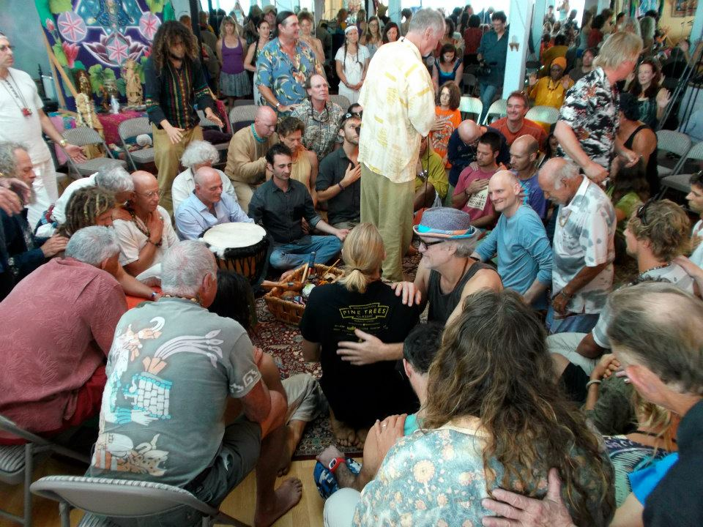

Aloha, My name is Ed Fell and I’m about to embark on an audacious teaching adventure.

I’m asking for your help. My Goal for this teaching and service endeavor is $50,000

Beginning this summer, I’m embarking on a University on Wheels tour around the world. In my years as therapist/coach, a Certified Leader in Mankind Project and other Wisdom schools, I’ve gathered a vast curriculum of teachings and knowledge; and now, I want to give back. YES! The sense of urgency for creating global change and leaving a legacy is important to me.

My plan is to purchase a used SUV and small trailer; pack it with a few belongings and lots of projects, teachings, writings and workshop material to last years of being on the road. At times, other visiting teachers will join me to offer their gifts to those who desire. I’ll park in communities that welcome me and are open to the group and individual experiences I offer. I’ll stay a while and then move to the next community. Next year my hope is to visit communities in Europe, N.Zealand, Australia and S. Africa.

How can you benefit?
- Sponsors can make use of my services at a discounted rate.
- Sponsors can feel good about supporting those who are unable to afford the work.
- Sponsors will be allies and ambassadors in co-creating positive change.
- Access to my on-line blog and video blogs on relevant life topics.

Offerings:
- Individual, Relationship and Group Sessions via in-person or through the zoom.

II. WE Groups: A radical and magical interactive group process that transcends separateness; honors difference, heals cultural rifts, creates connection and expanded awareness. WE groups grow into WE Communities…then real change happens.

III. Shadow watching and interventions skills training. To train leaders, boards and groups to discover and remove blocks that prevent higher functioning and healthier relationships. Together with Matrix (WE Group) Leadership Technology (MatrixLeadership.org), this work can radically shift a group and a community quickly.

IV. Sacred Intimacy for Committed Couples: Elevate your intimacy to that next level of connection and JOY.

V. Webinars and Blogs along the way.

VI. AND MUCH MORE

Goal: $50,000
Donations are for
1. Purchase of used SUV and small trailer.
2. An Apple Laptop Computer
3. Travel and Tech and misc. expenses

www.EdFell.com
808-419-8200
edfell3@gmail.com

Address: 35 A Huina Place, Kula, HI. 96790
Donations can be accepted via mail at the above address or…by clicking this:

http://edfell.com/faqs-payment/

Mahalo and Bless You For Your Support!

